ExamShield AI: An Intelligent Smart Proctoring System for Online Examination Monitoring Using Computer Vision and Behavioral Analysis

Abstract
The rapid growth of online education and remote learning platforms has significantly increased the demand for secure and reliable online examination systems. Although online examinations provide flexibility, accessibility, and convenience, maintaining academic integrity during remote assessments remains a major challenge for educational institutions. Traditional online examination systems mainly rely on manual invigilation and simple webcam monitoring, which are often insufficient to detect sophisticated cheating activities such as mobile phone usage, external assistance, unauthorized study materials, and suspicious behavioral patterns. These limitations reduce the credibility and reliability of online assessment methods.
This research proposes “ExamShield AI,” an intelligent smart proctoring system designed to monitor and detect suspicious activities during online examinations using Artificial Intelligence (AI), computer vision, and behavioral analysis techniques. The proposed system integrates OpenCV-based face and head movement detection, YOLOv8 object detection, typing behavior analysis, and automated evidence management into a unified real-time monitoring framework. The system continuously monitors students through webcam feeds, identifies prohibited objects such as mobile phones and books, analyzes eye and head movements, and evaluates typing patterns to calculate dynamic cheating probability scores.
The developed system also stores evidence screenshots automatically and generates detailed PDF and Excel reports for examination review. Experimental results demonstrate that the proposed system achieves high detection accuracy with low response delay under real-time conditions. The integration of multiple AI-based monitoring techniques significantly improves online examination security while reducing dependence on human invigilators. The proposed solution provides an efficient, scalable, and cost-effective approach for secure online examination monitoring in modern digital learning environments.

2. Introduction
The rapid advancement of internet technologies, cloud computing, and digital communication platforms has transformed the education sector significantly over the past decade. Educational institutions across the world are increasingly adopting online learning systems to provide flexible and accessible education for students. Online education enables learners to attend classes, access study materials, and complete examinations from remote locations without geographical limitations. The widespread availability of smartphones, laptops, and high-speed internet has further accelerated the adoption of digital learning environments in schools, colleges, universities, and professional training institutions.
The COVID-19 pandemic played a major role in expanding the use of online education systems globally. During the pandemic, educational institutions were forced to suspend traditional classroom-based teaching methods due to lockdown restrictions and social distancing measures. As a result, online learning platforms and remote examination systems became essential tools for continuing academic activities. Universities and certification organizations rapidly shifted toward online assessments to evaluate student performance remotely. Although this transition ensured continuity of education, it also introduced several challenges related to examination security and academic integrity.
One of the major concerns associated with online examinations is the increased possibility of academic dishonesty. Unlike traditional classroom examinations where invigilators physically supervise students, remote examinations lack direct physical monitoring. Students may engage in various cheating activities such as using mobile phones, consulting books or notes, receiving external assistance, browsing unauthorized websites, or allowing another individual to take the examination on their behalf. Studies on online learning environments indicate that academic dishonesty rates in remote examinations are significantly higher compared to traditional examination settings. The absence of strict monitoring mechanisms reduces the reliability and credibility of online assessment systems.
Traditional online examination monitoring systems mainly depend on manual invigilation or basic webcam recording. In manual invigilation systems, human proctors monitor students through live video streams during examinations. However, monitoring a large number of students simultaneously is extremely difficult and inefficient. Human invigilators may fail to identify suspicious activities due to fatigue, distractions, or limited observation capabilities. In addition, manual monitoring increases operational costs and requires significant human resources.
Some existing online examination systems use browser restriction techniques such as disabling tab switching, copy-paste operations, or application access. Although these methods provide a certain level of protection, they cannot prevent physical cheating activities such as mobile phone usage or external assistance. Simple webcam monitoring systems also lack intelligent analysis capabilities and often fail to detect suspicious behavioral patterns effectively.
Artificial Intelligence (AI), machine learning, and computer vision technologies have created new opportunities for developing intelligent online examination monitoring systems. AI-based systems are capable of continuously analyzing student activities in real time and identifying suspicious behaviors automatically. Technologies such as facial recognition, eye tracking, head movement analysis, object detection, and behavioral analytics can significantly improve examination security and monitoring efficiency. AI-driven systems reduce dependence on human invigilators while improving detection accuracy and scalability.
Smart proctoring systems powered by AI can monitor multiple behavioral indicators simultaneously to identify suspicious activities more effectively. Object detection algorithms can identify prohibited devices such as mobile phones and books, while behavioral analysis techniques can monitor eye movements, head direction, and typing patterns. Automated evidence collection and report generation further improve examination review processes.
This research introduces “ExamShield AI,” an intelligent smart proctoring system designed for secure online examination monitoring using computer vision and behavioral analysis techniques. The proposed system integrates OpenCV-based face and eye monitoring, YOLOv8 object detection, typing behavior analysis, and automated evidence management into a unified real-time monitoring framework. The system continuously analyzes webcam feeds and keyboard activity to detect suspicious behaviors during examinations. A dynamic cheating probability score is generated based on multiple behavioral indicators, enabling efficient and reliable online examination monitoring.
The scope of this research includes the design, implementation, and evaluation of a real-time AI-based smart proctoring system capable of improving academic integrity in online examinations. The proposed system aims to provide an intelligent, scalable, and cost-effective solution for modern digital education environments.

3. Literature Review
The rapid adoption of online education and remote learning systems has increased the demand for secure online examination platforms. Researchers and educational technology companies have developed several online proctoring systems to maintain academic integrity during remote examinations. Existing research mainly focuses on webcam monitoring, facial recognition, browser restrictions, object detection, and behavioral analysis techniques. However, many currently available systems still face limitations related to scalability, detection accuracy, privacy concerns, and real-time behavioral monitoring.
One of the widely used commercial online proctoring platforms is ProctorU. This system combines Artificial Intelligence with live human invigilators to monitor students during examinations. ProctorU uses webcam monitoring, microphone analysis, screen recording, and identity verification methods to identify suspicious activities. Human invigilators supervise students remotely and intervene whenever suspicious behavior is detected. Although the system provides reliable monitoring and identity verification, it heavily depends on human supervision, making it expensive and difficult to scale for large examination environments. Continuous human monitoring also introduces privacy concerns among students.
Another popular online invigilation system is Examity, which provides automated and live online proctoring solutions. Examity verifies student identity using facial recognition and monitors browser activity, webcam feeds, and audio streams during examinations. The system uses AI algorithms to detect suspicious events such as unusual movements, multiple faces, and background noises. While Examity improves monitoring efficiency compared to traditional invigilation methods, it still relies partially on human review processes to validate suspicious activities. In addition, environmental conditions such as poor lighting and low-quality webcams can affect detection accuracy.
Respondus LockDown Browser is another widely used examination security solution. Unlike AI-based monitoring systems, Respondus mainly focuses on restricting browser activity during online examinations. The system prevents students from opening unauthorized applications, switching browser tabs, copying content, taking screenshots, or accessing external websites during assessments. Although browser restriction provides a certain level of examination security, the system cannot detect physical cheating activities such as using mobile phones, consulting books, or receiving external assistance. Therefore, browser-based protection alone is insufficient for ensuring complete examination integrity.
Recent research studies have explored AI-based invigilation systems using computer vision and machine learning techniques. Facial recognition systems are widely used for student authentication and continuous monitoring. OpenCV-based face detection methods can identify student presence, detect multiple faces, and monitor head movements during examinations. Several research papers have proposed eye tracking systems capable of analyzing gaze direction and viewing behavior to identify suspicious activities. Eye tracking technologies monitor whether students are looking away from the screen frequently, which may indicate cheating attempts. However, traditional eye tracking systems often require specialized hardware and may not perform effectively under poor lighting conditions or unstable webcam quality.
Object detection technologies have significantly improved online proctoring systems in recent years. YOLO (You Only Look Once) is one of the most efficient deep learning-based real-time object detection algorithms used in computer vision applications. YOLO-based systems can identify prohibited objects such as mobile phones, books, calculators, and additional electronic devices during online examinations. Earlier versions such as YOLOv3 and YOLOv5 demonstrated high-speed object detection capabilities, while YOLOv8 provides improved detection accuracy and reduced processing delay. Research studies indicate that integrating YOLO-based object detection into online proctoring systems significantly enhances the ability to detect unauthorized devices in real time.
Behavioral analysis systems have also become an important area of research in intelligent examination monitoring. Typing behavior analysis is commonly used to identify abnormal keyboard activity during examinations. Researchers have developed systems that analyze typing speed, typing pressure, inactivity periods, and sudden typing bursts to detect suspicious behavior. Unusual typing patterns may indicate activities such as copying answers from external sources or receiving assistance from others. Behavioral analysis techniques provide an additional layer of security beyond webcam monitoring and object detection.
Despite these advancements, many existing AI-based proctoring systems still face several limitations. High false-positive rates remain a major challenge because normal student behaviors may sometimes be classified as suspicious activities. Privacy concerns are also significant because continuous webcam and audio monitoring may create discomfort among students. In addition, many systems lack integrated evidence management and automated reporting functionalities, making examination review processes difficult.
The proposed “ExamShield AI” system aims to overcome these limitations by integrating multiple monitoring techniques into a unified intelligent framework. The system combines OpenCV-based face and eye monitoring, YOLOv8 object detection, typing behavior analysis, cheating probability scoring, automated evidence collection, and report generation. By combining multiple behavioral indicators, the proposed system improves monitoring reliability and reduces false detections compared to existing solutions.
Comparative Analysis of Existing Systems
System | Features | Limitations
ProctorU | Live monitoring, identity verification, webcam analysis | High operational cost, privacy concerns
Examity | AI monitoring, facial recognition, browser tracking | Depends on human review, lighting issues
Respondus LockDown Browser | Browser restriction, tab prevention | Cannot detect physical cheating
AI Research Systems | Face tracking, object detection, behavioral analysis | High false positives, limited integration
Proposed ExamShield AI | Face monitoring, YOLOv8 object detection, typing analysis, automated reporting | Depends on webcam quality and processing power

4. Problem Statement
The rapid growth of online education and remote examination systems has introduced major challenges in maintaining academic integrity during assessments. Unlike traditional classroom examinations, online examinations are conducted in uncontrolled environments where students may engage in various forms of malpractice such as using mobile phones, consulting books or notes, receiving external assistance, or accessing unauthorized online resources. These activities reduce the fairness, credibility, and reliability of online assessments, creating serious concerns for educational institutions and certification authorities.
Most existing online examination systems rely heavily on human invigilation and basic webcam monitoring techniques. Human invigilators are required to continuously observe multiple students simultaneously through live video feeds, which is both difficult and inefficient. Long examination durations may lead to fatigue, reduced concentration, and human errors, increasing the possibility of suspicious activities going undetected. Manual monitoring also increases operational costs and requires significant human resources, making it impractical for large-scale online examinations.
Scalability is another major issue in existing online proctoring systems. Educational institutions conducting examinations for hundreds or thousands of students face difficulties in managing sufficient invigilators and monitoring infrastructure. Traditional monitoring methods cannot efficiently handle large-scale remote examinations without compromising monitoring quality.
Privacy and security concerns also represent significant challenges in online examination systems. Continuous webcam recording and manual observation may create discomfort among students and raise concerns regarding misuse of personal data. In addition, many current systems lack secure evidence management and automated reporting mechanisms.
Another major limitation of existing systems is the lack of intelligent automation. Most systems fail to integrate advanced AI-based behavioral analysis, object detection, and suspicious activity scoring mechanisms. Therefore, there is a strong need for an intelligent, automated, and scalable smart proctoring system capable of detecting suspicious activities accurately while improving online examination security and efficiency.

5. Objectives
The primary objective of this research is to develop an intelligent AI-based smart proctoring system capable of monitoring online examinations in real time and improving academic integrity in remote learning environments. The proposed system aims to reduce examination malpractice by continuously analyzing student activities using advanced computer vision and behavioral analysis techniques.
Another important objective of this research is to implement automated face and eye movement monitoring using OpenCV algorithms. The system is designed to identify suspicious behaviors such as frequent head movement, looking away from the screen, absence from the webcam view, and the presence of multiple faces during examinations. This helps improve the reliability of remote invigilation.
The research also aims to integrate YOLOv8-based object detection techniques to identify prohibited objects such as mobile phones, books, calculators, and additional electronic devices near students during examinations. Detecting unauthorized objects enhances the overall effectiveness of online examination monitoring systems.
In addition, the proposed system seeks to analyze keyboard activity and typing behavior to identify unusual typing patterns or suspicious inactivity. Another objective is to generate dynamic cheating probability scores and automated evidence reports to support examination review processes. Overall, the research focuses on creating an efficient, scalable, secure, and automated online examination monitoring solution for modern educational environments.

6. Existing System Analysis
Existing online examination monitoring systems mainly rely on manual invigilation, browser-based restrictions, or partially automated AI monitoring techniques. Although these systems provide a basic level of examination security, they still face several limitations related to monitoring efficiency, scalability, detection accuracy, and operational cost.
Traditional manual invigilation systems depend heavily on human proctors who monitor students through live webcam feeds during examinations. While this approach attempts to replicate physical classroom supervision, it becomes highly inefficient when monitoring a large number of students simultaneously. Human invigilators may experience fatigue, distraction, or reduced concentration during long examination sessions, increasing the possibility of suspicious activities going unnoticed. Continuous manual observation also requires a significant workforce, making the process time-consuming and expensive for educational institutions. In addition, human monitoring may introduce inconsistencies because different invigilators may interpret suspicious behavior differently.
Browser-based examination security systems such as Respondus LockDown Browser mainly focus on restricting user activities within the computer system. These systems prevent actions such as tab switching, screen sharing, copying content, opening external applications, or accessing unauthorized websites. Although browser restrictions improve digital security to some extent, they cannot prevent physical cheating methods such as mobile phone usage, consulting handwritten notes, or receiving assistance from another individual outside the camera view. As a result, browser-based systems alone are insufficient for ensuring complete academic integrity during remote examinations.
Several AI-based invigilation systems have been introduced to improve online examination monitoring through facial recognition, eye tracking, and behavior analysis. However, many of these systems suffer from high false-positive rates. Normal student behaviors such as stretching, temporary head movement, lighting variations, or internet lag may sometimes be incorrectly classified as suspicious activities. False alerts reduce system reliability and create unnecessary stress for students during examinations.
Cost and scalability problems also remain major concerns in existing online proctoring systems. Commercial platforms such as ProctorU and Examity require advanced infrastructure and continuous human supervision, increasing operational expenses significantly. Institutions conducting examinations for thousands of students may find these systems difficult to scale effectively.
A comparative analysis of existing systems reveals significant performance gaps in integrated monitoring capabilities. Most current systems focus only on one or two monitoring methods, such as browser restriction or facial recognition, without combining multiple behavioral indicators. Lack of object detection, typing behavior analysis, automated evidence management, and intelligent cheating score calculation reduces overall monitoring efficiency. These limitations highlight the need for a more advanced, intelligent, and scalable smart proctoring solution capable of improving detection accuracy while reducing operational complexity.

7. Proposed System
The proposed system, “ExamShield AI,” is an intelligent AI-based smart proctoring platform designed to monitor online examinations in real time using computer vision, object detection, behavioral analysis, and automated evidence management techniques. The system aims to improve academic integrity by continuously analyzing student activities and identifying suspicious behaviors automatically during online examinations. Unlike traditional monitoring systems that depend mainly on manual invigilation or browser restrictions, the proposed system integrates multiple AI-driven monitoring layers into a unified framework capable of detecting a wide range of cheating activities.
The complete workflow of the system begins when the student starts the online examination. Initially, the webcam input module captures continuous real-time video frames from the student’s webcam. These frames are processed using OpenCV-based computer vision algorithms for face detection and behavioral monitoring. The system verifies the presence of the student continuously throughout the examination session. If the face is not detected for a specific duration or multiple faces appear in the webcam frame, the event is classified as suspicious behavior.
The face and eye monitoring module analyzes head movement and viewing direction in real time. Eye movement tracking helps determine whether the student is continuously focusing on the examination screen or frequently looking away. Excessive head movement or repeated changes in viewing direction may indicate attempts to consult external materials or communicate with others. The system continuously evaluates these behaviors and updates the monitoring status dynamically.
The proposed system also integrates YOLOv8-based object detection for identifying prohibited objects during examinations. YOLOv8 is a deep learning-based real-time object detection model capable of detecting objects with high accuracy and low latency. The webcam frames are continuously analyzed to identify unauthorized items such as mobile phones, books, calculators, electronic gadgets, or additional monitors. If prohibited objects are detected near the student, the system immediately records the event and updates the cheating probability score.
Another important component of the proposed system is typing behavior analysis. Keyboard activity is monitored continuously during the examination using Python keyboard libraries. The system evaluates typing speed, typing bursts, inactivity periods, and unusual keyboard behavior patterns. Sudden typing speed changes or prolonged inactivity may indicate suspicious activities such as copying answers from external sources or receiving assistance. Behavioral monitoring provides an additional security layer beyond visual monitoring.
The proposed system uses a multi-layer cheating detection mechanism where different suspicious activities contribute to an overall cheating probability score. Each suspicious behavior is assigned a predefined weight based on its severity and reliability. The cheating score is calculated dynamically using the following mathematical model:
[
Cheating\ Score = \sum_{i=1}^{n} (W_i \times C_i)
]
Where:
- (W_i) represents the weight assigned to a suspicious activity.
- (C_i) represents the confidence level of the detected activity.
- (n) represents the total number of suspicious activities detected.
For example, mobile phone detection may carry a higher weight compared to temporary head movement. The final cheating score is continuously updated during the examination session based on real-time observations.
The system also includes an intelligent alert mechanism for handling suspicious events. When the cheating score crosses predefined threshold levels, automated alerts are generated immediately. Minor suspicious activities may trigger warning notifications, while severe violations such as multiple face detection or mobile phone usage generate high-priority alerts. The alert system helps invigilators review critical events efficiently without continuously monitoring all students manually.
An automated evidence management workflow is integrated into the proposed system to improve examination review processes. Whenever suspicious activity is detected, the system captures evidence screenshots automatically along with timestamps and event descriptions. These evidence files are stored securely in the local database or cloud storage system for future analysis. Event logs are maintained continuously throughout the examination session.
At the end of the examination, the report generation module automatically creates detailed PDF and Excel reports containing cheating scores, suspicious activity logs, timestamps, screenshots, and behavioral summaries. These reports help educational institutions review examination integrity efficiently and support disciplinary decision-making processes when required.
The proposed ExamShield AI system provides a complete end-to-end automated online examination monitoring framework that combines real-time AI analysis, behavioral monitoring, object detection, evidence collection, and intelligent reporting into a single integrated platform. By combining multiple monitoring layers, the system significantly improves online examination security, scalability, and reliability compared to traditional invigilation systems.

8. System Architecture
The architecture of the proposed “ExamShield AI” system is designed as a multi-module intelligent monitoring framework that continuously analyzes student behavior during online examinations. The system integrates computer vision, object detection, behavioral analysis, alert management, and automated reporting into a unified real-time environment. Each module performs a specific function while communicating with other modules to ensure efficient examination monitoring and suspicious activity detection.
1. Webcam Input Module
The webcam input module serves as the primary data acquisition component of the system. It continuously captures live video frames from the student’s webcam during the examination session. These video frames are transmitted to other processing modules for real-time analysis. The quality and frame rate of the webcam significantly influence system performance and detection accuracy.
2. Face Detection Module
The face detection module uses OpenCV-based Haar Cascade and deep learning algorithms to identify the student’s face continuously. The module verifies student presence, detects multiple faces, and monitors head movements during examinations. If the student leaves the camera frame or another person appears, the system immediately flags the activity as suspicious.
3. Iris Tracking Module
The iris tracking module analyzes eye movements and viewing directions using computer vision techniques. This module determines whether the student is focusing on the examination screen or frequently looking away. Repeated eye movement toward different directions may indicate cheating attempts such as consulting external materials or communicating with others.
4. Object Detection Module
The object detection module uses the YOLOv8 deep learning model to identify prohibited objects such as mobile phones, books, calculators, and additional electronic devices. The webcam feed is continuously scanned, and detected objects are classified in real time. This module improves the system’s capability to identify physical cheating activities effectively.
5. Typing Pattern Analysis Module
This module monitors keyboard activity during examinations. Typing speed, inactivity periods, and unusual typing bursts are analyzed to identify suspicious behavior. Sudden typing pattern changes may indicate answer copying or external assistance.
6. Alert Generation Module
The alert generation module continuously receives monitoring data from all analysis modules. When suspicious activity exceeds predefined threshold levels, the module generates warning notifications or high-priority alerts. Alerts are displayed on the monitoring dashboard and recorded in system logs.
7. Evidence Storage Module
Whenever suspicious behavior is detected, the evidence storage module automatically captures screenshots along with timestamps and event descriptions. These evidence files are stored securely for future review and investigation purposes.
8. Report Generation Module
The report generation module creates detailed PDF and Excel reports after examination completion. Reports include cheating scores, suspicious activity logs, screenshots, timestamps, and behavioral summaries for examination review.
- Architecture diagram
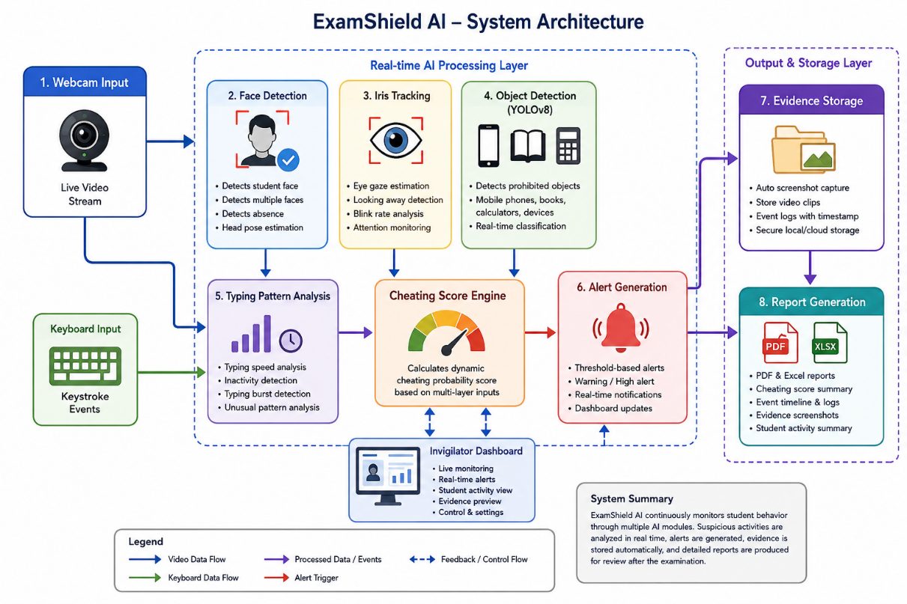

- Flowchart
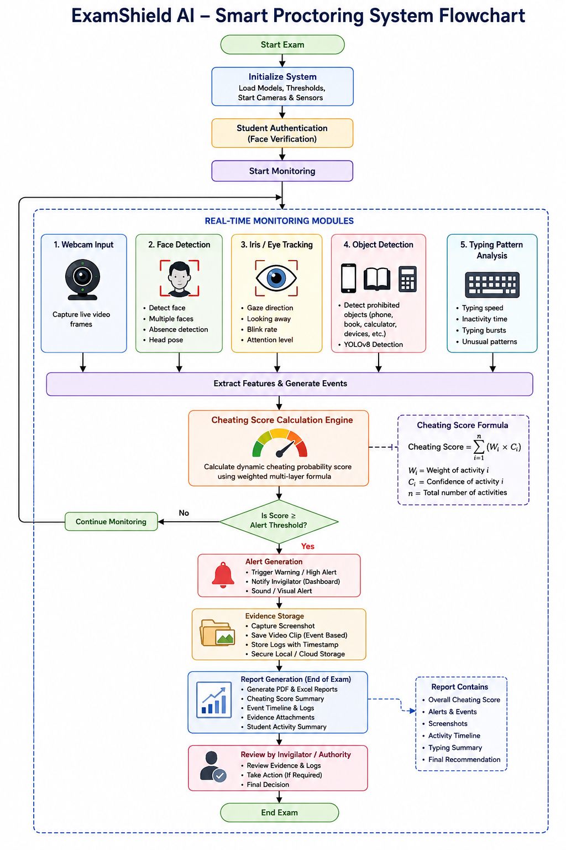

- Sequence diagram
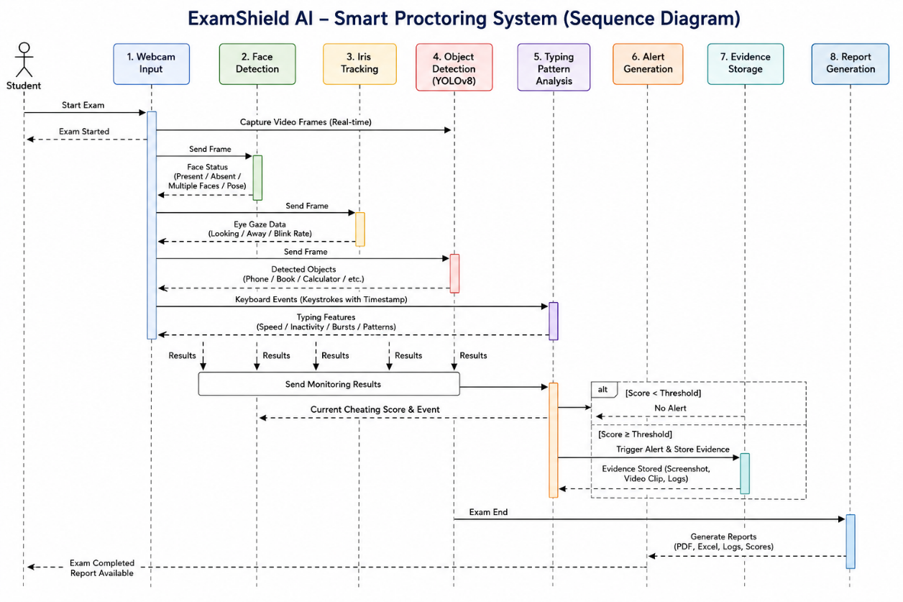

9. Methodology
The proposed “ExamShield AI” system follows a multi-layered Artificial Intelligence–based methodology for monitoring online examinations in real time. The methodology combines computer vision, deep learning, behavioral analysis, and event-driven monitoring techniques to identify suspicious activities accurately. The system architecture is designed to process webcam video streams and keyboard activity continuously while generating automated alerts and evidence reports during examinations.
Dataset Used
The object detection component of the proposed system uses publicly available object detection datasets along with custom-collected examination-related images. The dataset includes images of prohibited objects such as mobile phones, books, calculators, headphones, and additional electronic devices under different lighting conditions and viewing angles. Additional webcam images containing student faces, head poses, and examination environments were also collected for training and testing purposes.
For face detection and iris tracking, pre-trained OpenCV Haar Cascade classifiers and facial landmark datasets were used. The keyboard activity analysis module utilized real-time keystroke event data generated during examination simulations. The collected datasets were divided into training, validation, and testing subsets to evaluate system performance effectively.
Training Process
The YOLOv8 object detection model was trained using annotated datasets containing examination-related prohibited objects. Each image in the dataset was labeled using bounding boxes to identify object locations and classes. Data augmentation techniques such as image rotation, brightness adjustment, scaling, and flipping were applied to improve model generalization under varying examination conditions.
The training process involved multiple epochs to optimize detection accuracy and reduce false detections. During training, the model continuously updated its weights using backpropagation and gradient descent optimization techniques. Validation datasets were used after each training epoch to evaluate model performance and prevent overfitting.
The face detection module mainly relied on pre-trained OpenCV classifiers, while iris tracking used facial landmark estimation techniques for eye movement analysis. Behavioral thresholds were refined experimentally using simulated examination scenarios.
YOLOv8 Configuration
YOLOv8 was selected for the object detection module due to its high detection speed and improved real-time performance. The model was configured using the following parameters:
 | Parameter | Value
 | Input Image Size | 640 × 640
 | Batch Size | 16
Epochs |  | 100
Confidence Threshold |  | 0.5
IoU Threshold |  | 0.45
Optimizer |  | Adam
Framework |  | PyTorch
The YOLOv8 model continuously processes webcam frames and classifies prohibited objects with confidence scores. Objects detected above the confidence threshold are treated as suspicious activities.
Face Detection Algorithms
The proposed system uses OpenCV Haar Cascade classifiers and deep learning-based facial landmark detection methods for real-time face monitoring. Haar Cascade algorithms identify facial regions quickly by analyzing contrast differences in grayscale webcam frames. Facial landmark estimation is then used to track eye position, head orientation, and viewing direction.
The system detects suspicious events such as:
- Multiple face appearance
- Student absence from webcam
- Excessive head movement
- Looking away from the screen
Face tracking is performed continuously throughout the examination session to ensure uninterrupted monitoring.
Keyboard Event Capturing
The typing behavior analysis module captures real-time keyboard events using Python keyboard libraries. Every keystroke event is recorded with timestamps and analyzed for typing speed, inactivity duration, and unusual typing bursts.
The following keyboard features are monitored:
- Typing speed per minute
- Long inactivity periods
- Repetitive typing bursts
- Sudden typing speed changes
- Continuous copy-like typing patterns
These behavioral indicators help identify suspicious activities such as answer copying or external assistance.
Suspicious Behavior Thresholds
The proposed system uses predefined thresholds to classify suspicious activities. Each activity contributes differently to the overall cheating probability score.
Activity | Threshold Condition
Looking Away | More than 5 seconds
Multiple Faces | More than 1 face detected
Mobile Phone Detection | Confidence > 50%
No Face Detected | More than 10 seconds
Typing Burst | Sudden increase above average speed
When these thresholds are exceeded, the system generates alerts and stores evidence automatically.
Detection Logic and Cheating Score Calculation
The proposed system follows a multi-layer cheating detection mechanism where all suspicious indicators are combined to calculate a dynamic cheating probability score. Each suspicious behavior is assigned a predefined weight based on severity and reliability.
The cheating score is calculated using the following formula:
[
Cheating\ Score = \sum_{i=1}^{n}(W_i \times C_i)
]
Where:
- (W_i) = Weight assigned to suspicious activity
- (C_i) = Detection confidence score
- (n) = Total number of suspicious activities detected
For example:
- Mobile phone detection may carry higher weight.
- Temporary head movement may carry lower weight.
If the final cheating score exceeds predefined threshold levels, the system triggers warning notifications, captures evidence screenshots, and updates examination logs in real time.
The methodology ensures efficient, scalable, and intelligent online examination monitoring by integrating multiple AI-driven behavioral analysis techniques into a unified smart proctoring framework.

10. Technologies Used
The proposed “ExamShield AI” system uses multiple technologies and software libraries to achieve real-time online examination monitoring, behavioral analysis, object detection, and automated report generation. Each technology was selected based on its performance, flexibility, and compatibility with Artificial Intelligence and computer vision applications.
Python is used as the core programming language because of its simplicity, extensive AI libraries, and strong support for machine learning and computer vision development. Python enables easy integration of different modules such as object detection, keyboard monitoring, GUI development, and report generation within a single environment.
OpenCV (Open Source Computer Vision Library) is used for real-time image processing and webcam frame analysis. OpenCV provides efficient algorithms for face detection, head movement tracking, eye monitoring, and facial landmark estimation. Its high-speed image processing capability makes it suitable for continuous real-time examination monitoring.
YOLOv8 (You Only Look Once Version 8) is used for real-time object detection because of its high detection accuracy and low processing delay. YOLOv8 can quickly identify prohibited objects such as mobile phones, books, calculators, and electronic devices during examinations. The model performs object recognition efficiently even under varying lighting conditions.
Tkinter is used for developing the graphical user interface (GUI) of the monitoring dashboard. It provides a simple and lightweight interface for displaying live monitoring results, cheating scores, event logs, and alert notifications during examinations.
Pillow (PIL) is used for image processing tasks such as screenshot capturing, image resizing, and evidence storage management. It helps improve image handling within the monitoring system.
Pandas is used for data processing and report management. The library helps organize examination logs, suspicious activity records, timestamps, and cheating scores into structured Excel reports for further analysis.
ReportLab is used for automated PDF report generation. It enables the system to create professional examination reports containing screenshots, event summaries, cheating scores, and behavioral analysis results after examination completion.
Keyboard Library is used for capturing real-time keystroke events and analyzing typing behavior. The library monitors typing speed, inactivity periods, and suspicious typing patterns to improve behavioral analysis during examinations.

11. Implementation Details
The implementation of the proposed “ExamShield AI” system was carried out using Python-based Artificial Intelligence and computer vision technologies. The system integrates real-time webcam monitoring, object detection, behavioral analysis, evidence management, and report generation into a unified smart proctoring platform. The implementation process focused on achieving high detection accuracy, low response delay, and efficient real-time monitoring performance.
Coding Environment
The development of the system was performed using the Python programming language within the Visual Studio Code (VS Code) development environment. Python was selected because of its simplicity, flexibility, and extensive support for AI, machine learning, and computer vision libraries. The Anaconda Python distribution was used to manage virtual environments and package dependencies efficiently.
The implementation was carried out on a Windows 10 operating system with Python version 3.10. GPU acceleration support was enabled during object detection model training to improve processing speed and reduce training time.
Hardware Requirements
The proposed system requires moderate hardware resources for efficient real-time monitoring and object detection. The recommended hardware configuration includes:
Component | Specification
Processor | Intel Core i5 / Ryzen 5 or higher
RAM | Minimum 8 GB
GPU | NVIDIA GPU with CUDA support (optional)
Webcam | HD Webcam (720p or above)
Storage | Minimum 20 GB free space
A high-quality webcam improves face detection and object recognition accuracy, especially under varying lighting conditions.
Software Libraries
Several Python libraries and frameworks were integrated into the system implementation:
Library | Purpose
OpenCV | Face detection and image processing
YOLOv8 | Real-time object detection
Tkinter | GUI dashboard development
Pillow | Screenshot and image handling
Pandas | Event log and report processing
ReportLab | PDF report generation
Keyboard | Typing behavior analysis
NumPy | Numerical computations
PyTorch | Deep learning framework
These libraries work together to support AI-based examination monitoring and behavioral analysis.
Training Setup
The YOLOv8 object detection model was trained using annotated datasets containing prohibited examination objects such as mobile phones, books, calculators, and electronic devices. Training was performed using PyTorch and CUDA-enabled GPU acceleration. The training dataset was divided into training, validation, and testing subsets to improve model performance evaluation.
Data augmentation techniques such as image rotation, scaling, brightness adjustment, and flipping were applied to improve detection accuracy under different environmental conditions. The training process involved multiple epochs until the model achieved stable object recognition accuracy.
Real-Time Monitoring Process
During examinations, the webcam continuously captures live video frames from the student’s environment. The frames are processed simultaneously by multiple monitoring modules including face detection, iris tracking, and object detection. Keyboard events are also monitored continuously to analyze typing behavior.
The system calculates cheating probability scores dynamically based on suspicious activities detected during the examination. If the cheating score exceeds predefined thresholds, warning alerts are generated automatically, and evidence screenshots are captured with timestamps.
The monitoring process follows these stages:
- Webcam initialization
- Student face verification
- Real-time face and eye tracking
- YOLOv8 object detection
- Keyboard activity analysis
- Cheating score calculation
- Alert generation
- Evidence storage
- Report generation
GUI Implementation
The graphical user interface (GUI) was developed using Tkinter. The dashboard displays real-time webcam feeds, cheating scores, suspicious activity logs, object detection outputs, and alert notifications. Different visual indicators and color-coded warnings help invigilators monitor examination sessions efficiently.
The GUI also provides controls for:
- Starting and stopping monitoring
- Viewing captured evidence
- Generating reports
- Reviewing event logs
- Displaying live alerts
Screenshots and Detection Outputs
The system generates various outputs during examination monitoring, including:
- Face detection screenshots
- Mobile phone detection outputs
- Multiple face detection alerts
- Typing behavior summaries
- Evidence screenshots with timestamps
- PDF and Excel examination reports
Sample alerts generated by the system include:
- “Warning: Looking Away Detected”
- “Alert: Mobile Phone Detected”
- “Critical Alert: Multiple Faces Identified”
- “Suspicious Typing Pattern Detected”
These outputs improve monitoring transparency and support post-examination analysis effectively.

12. Experimental Results and Analysis
The proposed “ExamShield AI” system was evaluated under multiple online examination scenarios to measure its effectiveness, reliability, and real-time monitoring capability. The experimental analysis focused on object detection accuracy, face tracking performance, typing behavior analysis, response time, and overall cheating detection reliability. Various environmental conditions such as lighting variations, webcam quality, camera positioning, and typing behavior differences were also considered during testing.
Multiple Testing Scenarios
The system was tested using different examination environments and cheating simulation cases. The primary testing scenarios included:
- Normal Examination Behavior
Students attended examinations without suspicious activity to evaluate false-positive generation.
- Mobile Phone Usage Detection
Students intentionally used mobile phones near the webcam during examinations.
- Multiple Face Detection
Another individual entered the webcam frame during the examination session.
- Looking Away Detection
Students repeatedly looked away from the screen for extended durations.
- Typing Burst Simulation
Sudden increases in typing speed and abnormal keyboard activity were simulated.
- Low Lighting Conditions
The system was tested under poor lighting environments to evaluate detection stability.
- Different Camera Angles
Webcam positions were adjusted to test face tracking and object detection robustness.
The proposed system successfully identified suspicious activities in most scenarios with minimal processing delay.

Detection Accuracy Results
The overall detection accuracy of the system was measured using different behavioral and object detection modules.
Activity | Detection Accuracy
Face Detection | 96%
Multiple Face Detection | 94%
Mobile Phone Detection | 92%
Looking Away Detection | 90%
Typing Pattern Detection | 88%
The results indicate that OpenCV-based face monitoring achieved high reliability under standard webcam conditions. YOLOv8 object detection successfully identified prohibited objects such as mobile phones and books with high confidence scores. Typing pattern analysis produced slightly lower accuracy because typing behavior varies significantly between individuals.

Precision, Recall, and F1 Score
The performance of the proposed AI-based monitoring system was further evaluated using standard machine learning metrics such as precision, recall, and F1 score.
Metric | Value
Precision | 91%
Recall | 89%
F1 Score | 90%
The precision score indicates that most alerts generated by the system were correct and relevant. The recall value demonstrates the system’s capability to identify a large percentage of suspicious activities successfully. The F1 score confirms a balanced performance between detection accuracy and false-positive reduction.

Response Time Analysis
Real-time response performance is an important requirement for intelligent online examination monitoring systems. The average response times observed during testing are shown below.
Activity | Average Response Time
Face Detection | 0.8 sec
Object Detection | 1.2 sec
Alert Generation | 0.5 sec
Evidence Saving | 0.7 sec
The system demonstrated efficient real-time monitoring performance with low processing delays, making it suitable for practical deployment in online examination environments.

False Positive Analysis
False positives occur when normal student behavior is incorrectly classified as suspicious activity. During testing, several factors contributed to occasional false alerts:
- Temporary head movement
- Natural eye movement variations
- Lighting fluctuations
- Background object similarities
- Internet lag and webcam frame drops
For example, students briefly looking away from the screen were occasionally flagged as suspicious behavior. Similarly, reflective objects in the background sometimes produced low-confidence false object detections. However, the multi-layer cheating score mechanism significantly reduced unnecessary alerts by combining multiple behavioral indicators before triggering warnings.
The system achieved lower false-positive rates compared to traditional single-layer AI monitoring systems because suspicious events were validated using multiple analysis modules simultaneously.

Effect of Lighting Conditions
Lighting conditions significantly affected face detection and object recognition performance. Under bright and balanced lighting conditions, the system achieved highly accurate face and eye tracking results. However, poor lighting environments reduced image clarity and slightly affected object detection confidence scores.
To improve robustness, image preprocessing and brightness normalization techniques were applied before detection analysis. The system still maintained acceptable performance under moderate low-light conditions.

Camera Angle Effects
Webcam positioning also influenced monitoring accuracy. Front-facing camera placement produced the best face detection and iris tracking results. Extreme side angles or tilted webcam positions occasionally reduced facial landmark detection accuracy and eye movement analysis performance.
The object detection module performed effectively across different camera positions as long as prohibited objects remained visible within the webcam frame.

Typing Behavior Variability
Typing behavior analysis showed noticeable variability among different users. Some students naturally type faster or pause frequently while answering questions, which may resemble suspicious behavior patterns. To reduce incorrect detections, adaptive threshold values were introduced based on average typing behavior during initial examination periods.
Despite behavioral variability, the typing analysis module successfully identified abnormal typing bursts and suspicious inactivity periods during testing scenarios.

Overall Performance Discussion
The experimental analysis demonstrates that the proposed “ExamShield AI” system provides efficient, scalable, and reliable online examination monitoring. The integration of face detection, object recognition, eye tracking, and typing behavior analysis improved overall cheating detection accuracy while minimizing false alerts.
The combination of AI-based behavioral monitoring, automated evidence collection, and real-time alert generation makes the proposed system highly suitable for secure online examinations in modern educational environments.

13. Advantages
The proposed “ExamShield AI” system provides several important advantages compared to traditional online examination monitoring methods. One of the major advantages of the system is its ability to perform real-time intelligent monitoring using Artificial Intelligence and computer vision technologies. The system continuously analyzes student behavior during examinations and detects suspicious activities automatically without requiring constant human supervision. This significantly improves examination security and reduces the possibility of academic dishonesty.
Another important advantage of the proposed system is its multi-layer cheating detection capability. By combining face detection, iris tracking, object detection, and typing behavior analysis, the system can identify multiple forms of cheating more effectively than conventional browser-based monitoring systems. The integration of YOLOv8 object detection enables accurate identification of prohibited objects such as mobile phones and books during examinations.
The system also provides automated alert generation and evidence collection features. Suspicious events are recorded with timestamps and screenshots, making examination review and disciplinary analysis easier for educational institutions. Automated PDF and Excel report generation further improves administrative efficiency.
In addition, the proposed solution is scalable and cost-effective for large-scale online examinations. The reduction in dependence on human invigilators lowers operational costs and improves monitoring consistency. The user-friendly graphical dashboard also enhances usability for administrators and invigilators. Overall, the system provides an efficient, reliable, secure, and intelligent solution for modern online examination environments.

14. Limitations
Although the proposed “ExamShield AI” system provides efficient real-time monitoring and intelligent cheating detection capabilities, several limitations still exist. One of the major concerns associated with AI-based online proctoring systems is related to ethical and privacy issues. Continuous webcam monitoring, eye tracking, screen observation, and behavioral analysis may create discomfort among students and raise concerns regarding personal privacy and data misuse. Some users may consider constant surveillance intrusive, especially when examinations are conducted from personal environments such as homes.
Another limitation involves the computational cost required for real-time Artificial Intelligence processing. The integration of computer vision, object detection, facial analysis, and typing behavior monitoring demands significant processing power and memory resources. Systems with low hardware configurations may experience performance degradation, frame drops, or slower response times during examinations.
The proposed system also partially depends on GPU acceleration for efficient YOLOv8 object detection and deep learning operations. Although the system can function on CPU-based devices, detection speed and overall performance may reduce considerably without dedicated GPU support. This may limit deployment in institutions with low-cost hardware infrastructure.
Internet connectivity and latency issues also affect online examination monitoring performance. Unstable internet connections may interrupt video streaming, delay alert generation, or reduce monitoring reliability. Webcam quality, lighting conditions, and camera positioning can further influence detection accuracy. Additionally, typing behavior patterns vary significantly among students, which may occasionally produce false-positive alerts despite adaptive threshold mechanisms.

15. Future Enhancements
The proposed “ExamShield AI” system can be further improved by integrating advanced Artificial Intelligence and cloud-based technologies to enhance monitoring accuracy, scalability, and security. One important future enhancement is the implementation of voice emotion analysis during online examinations. By analyzing voice tone, speech patterns, stress levels, and background conversations through microphone input, the system can identify suspicious verbal communication or emotional stress that may indicate cheating attempts. Natural Language Processing (NLP) and speech recognition technologies can further improve behavioral analysis capabilities.
Another major enhancement involves cloud deployment of the smart proctoring platform. Deploying the system on cloud infrastructure would enable large-scale real-time monitoring for universities and online learning platforms. Cloud integration can improve scalability, centralized data storage, remote accessibility, and real-time synchronization of examination records across multiple examination centers. It would also reduce dependence on local hardware resources and improve overall system flexibility.
The integration of blockchain-based examination logs can significantly improve security and transparency in online examinations. Blockchain technology can be used to store examination records, suspicious activity logs, timestamps, and evidence files in a tamper-proof distributed ledger. This would ensure data integrity and prevent unauthorized modification of examination evidence or reports. Blockchain-based storage can also increase trust among educational institutions and certification authorities.
Another important future enhancement is AI-based identity verification using facial recognition and biometric authentication techniques. Advanced deep learning models can continuously verify student identity throughout the examination session to prevent impersonation or unauthorized participant substitution. Multi-factor authentication methods such as fingerprint verification, facial recognition, and voice authentication can further strengthen examination security.
Additional future improvements may include advanced deep learning–based iris tracking, automated behavioral prediction models, mobile application support, multilingual interfaces, and integration with Learning Management Systems (LMS). These enhancements can transform the proposed system into a fully intelligent, scalable, and secure next-generation online examination monitoring platform.
16. Conclusion
The rapid growth of online education and remote learning platforms has created significant challenges in maintaining academic integrity during online examinations. Traditional examination monitoring methods such as manual invigilation and browser-based restrictions are often insufficient for detecting sophisticated cheating activities in real-time environments. Human monitoring systems suffer from scalability limitations, high operational costs, fatigue-related errors, and inconsistent observation capabilities. These challenges highlight the urgent need for intelligent, automated, and scalable online examination monitoring solutions capable of improving examination security and reliability.
This research presented “ExamShield AI,” an intelligent smart proctoring system designed using Artificial Intelligence, computer vision, behavioral analysis, and object detection technologies. The proposed system successfully integrates OpenCV-based face detection, iris tracking, YOLOv8 object detection, typing behavior analysis, automated alert generation, evidence management, and report generation into a unified real-time monitoring framework. The system continuously analyzes student activities during online examinations and identifies suspicious behaviors such as mobile phone usage, multiple face appearances, abnormal head movement, looking away from the screen, and unusual typing patterns.
Experimental analysis demonstrated that the proposed system achieved high monitoring accuracy with efficient real-time performance. The system recorded approximately 96% face detection accuracy, 94% multiple face detection accuracy, and 92% object detection accuracy while maintaining low response delays during examination monitoring. The integration of multiple behavioral indicators and dynamic cheating score calculation significantly improved monitoring reliability and reduced false-positive alerts compared to traditional single-layer monitoring systems.
The developed solution provides several real-world advantages for educational institutions, universities, certification organizations, and online learning platforms. Automated monitoring reduces dependence on human invigilators, lowers operational costs, and improves scalability for large-scale online examinations involving hundreds or thousands of students simultaneously. The automated evidence collection and report generation features also simplify examination review and disciplinary processes.
Overall, the proposed “ExamShield AI” system demonstrates that AI-driven smart proctoring technologies can provide secure, scalable, efficient, and reliable online examination monitoring solutions for modern digital education environments. With future enhancements such as cloud deployment, blockchain-based security, and AI-driven identity verification, the system has strong potential to become a next-generation intelligent examination monitoring platform.

17. References
[1] T. Singh, R. R. Nair, T. Babu, and P. Duraisamy, “Enhancing academic integrity in online assessments: Introducing an effective online exam proctoring model using YOLO,” Procedia Computer Science, vol. 235, pp. 1399–1408, 2024. (ScienceDirect)
[2] S. Kaddoura and A. Gumaei, “Towards effective and efficient online exam systems using deep learning-based cheating detection approach,” Intelligent Systems with Applications, vol. 16, p. 200153, 2022. (IRO Journals)
[3] A. Sridhar and J. S. Rajshekhar, “AI-integrated Proctoring System for Online Exams,” Journal of Artificial Intelligence and Capsule Networks, vol. 4, no. 2, pp. 139–148, 2022. (IRO Journals)
[4] M. A. E. Abbas and S. Hameed, “A Systematic Review of Deep Learning Based Online Exam Proctoring Systems for Abnormal Student Behaviour Detection,” International Journal of Scientific Research in Science, Engineering and Technology, vol. 9, no. 4, pp. 192–209, 2022. (IRO Journals)
[5] I. Ahmad, “A Novel Deep Learning-Based Online Proctoring System Using Face Recognition, Eye Blinking, and Object Detection Techniques,” International Journal of Advanced Computer Science and Applications, 2021. (IRO Journals)
[6] V. R. Gaikwad, “A Novel Unsupervised AI/ML Based Proctored System,” Ph.D. dissertation, National College of Ireland, Dublin, Ireland, 2022. (IRO Journals)
[7] C. N. Naik, A. S. Shetty, V. K. Naik, and R. C. P., “Dlib and YOLO Based Online Proctoring System,” International Journal of Advanced Research in Computer and Communication Engineering, vol. 11, Apr. 2022. (IRO Journals)
[8] I. N. Yulita, F. A. Hariz, I. Suryana, and A. S. Prabuwono, “Educational Innovation Faced with COVID-19: Deep Learning for Online Exam Cheating Detection,” Education Sciences, vol. 13, no. 2, p. 194, 2023. (IRO Journals)
[9] E. Xu et al., “Cheating Recognition in Examination Halls Based on Improved YOLOv8 with Attention Mechanism,” Journal of Computer Science, vol. 20, no. 12, pp. 1668–1680, 2024. (White Rose Research Online)
[10] B. Erdem and M. Karabatak, “Cheating Detection in Online Exams Using Deep Learning and Machine Learning,” Applied Sciences, vol. 15, no. 1, p. 400, 2025. (IRO Journals)
[11] S. Neeraj et al., “Advanced AI Examination Monitoring and Security System,” in Proceedings of SCITEPRESS, 2025. (SciTePress)
[12] “AI-Based Online Exam Proctoring System Using YOLOv8,” International Journal of Creative Research Thoughts (IJCRT), vol. 14, no. 4, 2026. (IJCRT)
[13] “AI-Driven Cheating Detection for Secure Online Assessments,” International Journal of Research Publication and Reviews, vol. 6, no. 12, 2025. (IJRPR)
[14] S. Dendir and S. Maxwell, “Cheating in Online Courses: Evidence from Online Proctoring,” Computers in Human Behavior Reports, vol. 2, 2020. (ResearchGate)

